NGO MANAGEMENT SYSTEM
Use Case Document


 | Prepared By / Last Updated By | Prepared By / Last Updated By | Prepared By / Last Updated By | Prepared By / Last Updated By | Prepared By / Last Updated By | Reviewed By | Approved By
Name | Aayushi Sen | Richa Nema | Geet Jigyasi | Ayushi Agarwal | Poornima Singh | Venkatesh Badiger
Role | Team Member | Team Member | Team Member | Team Member | Team Member | Trainer
Date | 28/03/19 | 28/03/19 | 28/03/19 | 28/03/19 | 28/03/19 | 28/03/19

Table of Contents
1.0 Introduction 3
1.1 Purpose & Scope of the document 3
1.2 Intended Audience 3
1.3 Use case ‘User Registration’ 3
1.3.1 Use case attributes 3
1.3.2 Use Case Model 4
1.3.3 Business Rules 4
1.3.4 UI Requirements 4
1.3.5 UI Field Validations 5
1.4 Use case ‘User Credential Authentication’ 6
1.4.1 Use case attributes 6
1.4.2 Use Case Model 7
1.4.3 Business Rules 7
1.4.4 UI Requirements 7
2.0 Database Design 8
2.1 Tables Structure 8
3.0 Change Log 10

Introduction

Purpose & Scope of the document
The purpose of this Use case document is to systematically capture requirements for the project and the system to be developed in terms of use cases. Functional use cases are captured in this document. It also serves as the input for the project scoping.

The scope of this document is limited to addressing the use cases from a user, quality, and non-functional perspective.

Intended Audience
Each member of the project team

Use case ‘User/NGO Registration’

Use case attributes
Use Case Description:

This use case deals with the capture of user/NGO details. The user will be posting requirements of the events whereas the NGO will be helping those users for their events.

Scope:

- User registration
- NGO registration

Actors:

- User
- NGO

Trigger:

Click ‘Signup’ button in the ‘User/NGO Registration’ page

Pre-Condition:

User being able to access the homepage & get redirected to the ‘User/NGO Registration’ page upon click of ‘Signup as User’ or ’Signup as NGO’ link.

Post Condition:

User/NGO is in the register page & submit details

Flow of Events:

User/NGO at homepage →Click ‘Signup as User’ or ’Signup as NGO’ link → User/NGO is in the register page → User/NGO details are submitted and added onto the database.

Primary Scenario:
A new user/NGO – is able to click ‘Signup as User’ or ’Signup as NGO’ link and is able to provide his details and get registered in the system.

Use Case Model
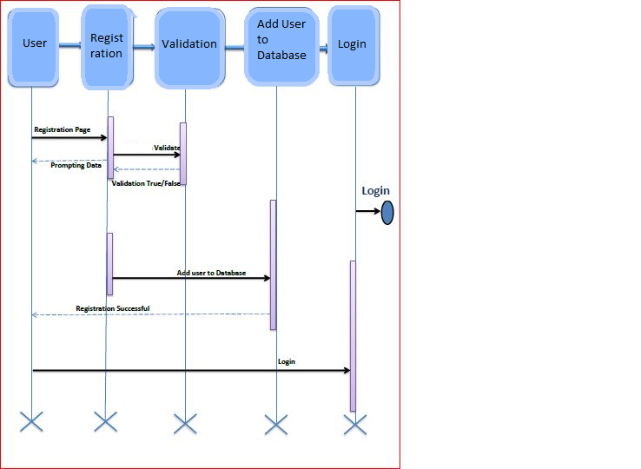

Business Rules

Business rules should be defined using the following attributes: -

- When the user/NGO clicks on the registration link, it should re-direct to registration form.
    - User/NGO needs to fill some of the basic attributes/fields as mentioned below in requirement: First Name, Last Name, Age, Gender, Contact Number, User Id, Password
- Clicking ‘Submit’ should validate the datatype constraints for each field
- Post-successful field level validation, save the information in the database
- Upon saving the information in the database, display the message ‘Your details are submitted successfully’.

UI Requirements
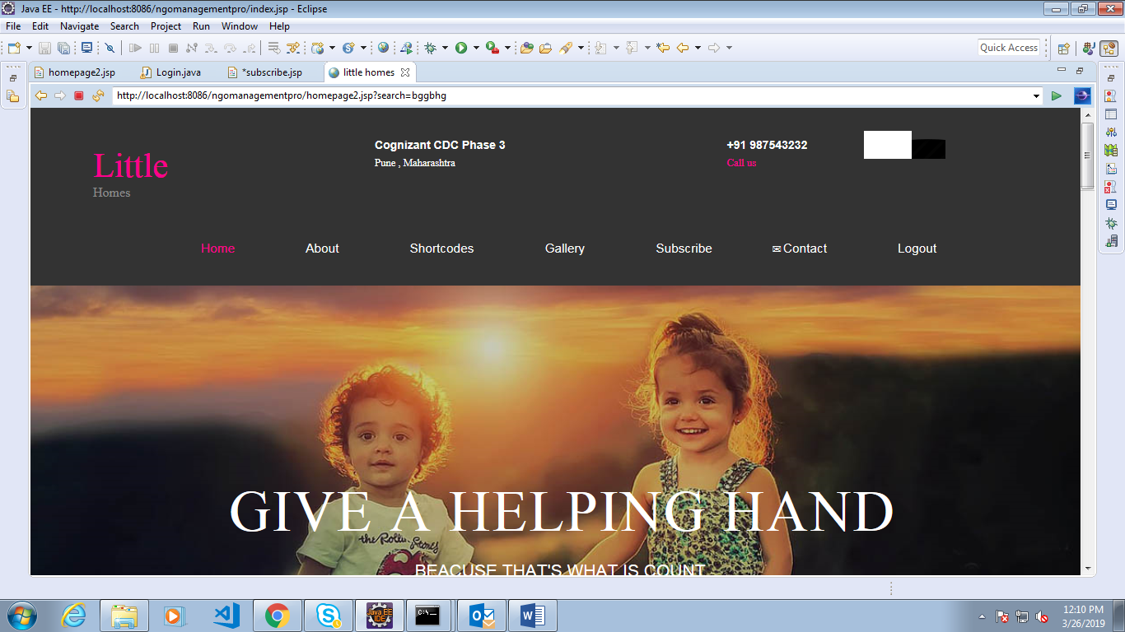
Here is a prototype on how the homepage should look like.

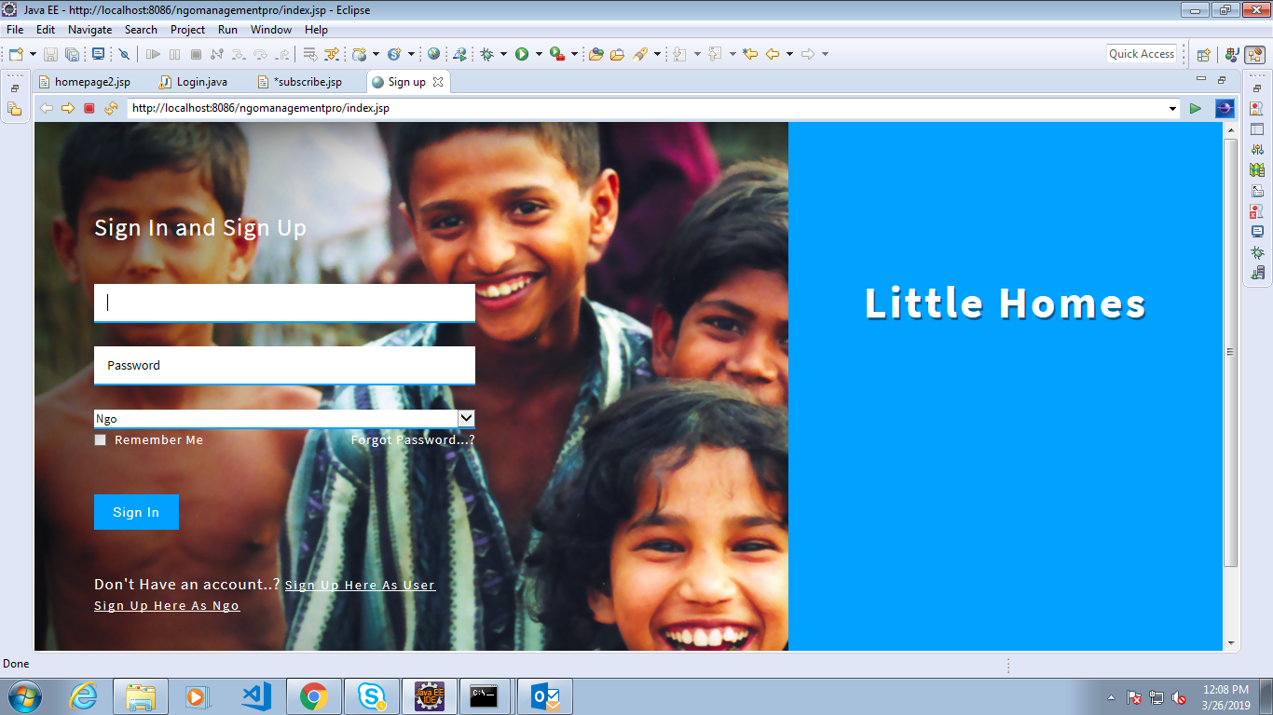

Here is a prototype on how the Sign In should look like.

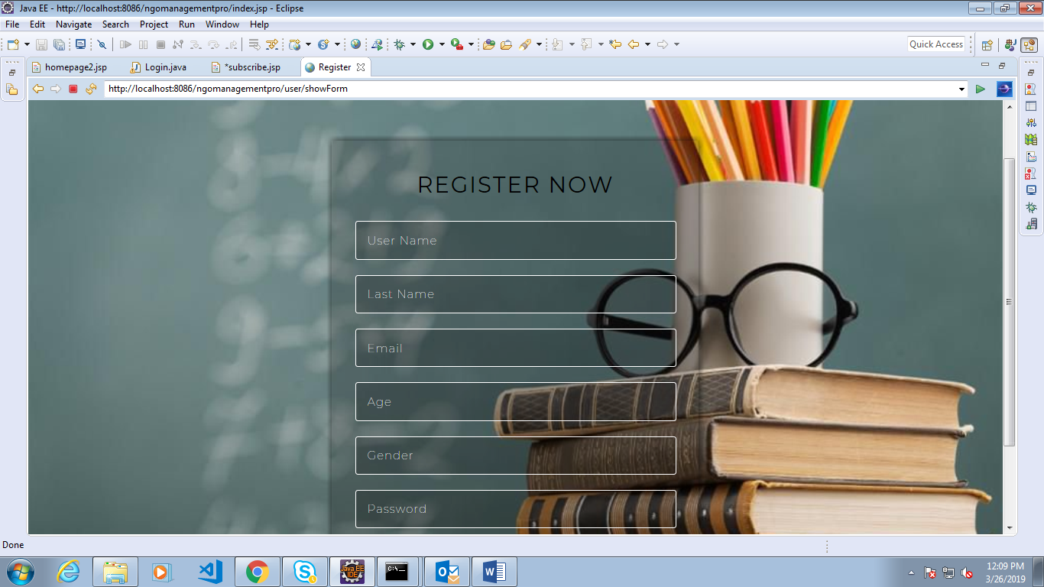

Here is a prototype on how the ‘User Registration’ page should look like.
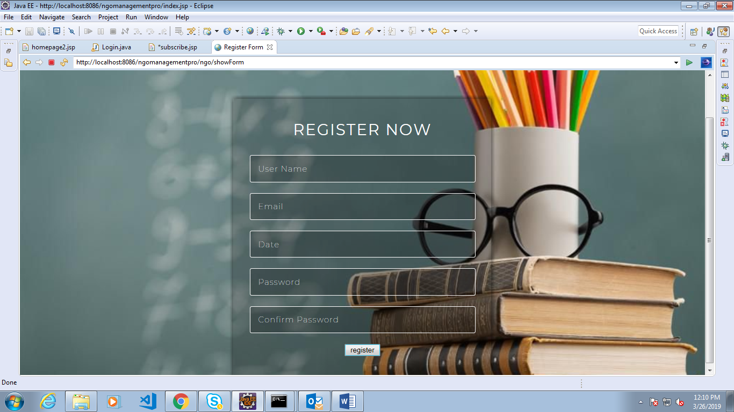

Here is a prototype on how the ‘NGO Registration’ page should look like.

UI Field Validations
Please refer to the below requirements for field level validations:

- All fields are mandatory.
- Username should be less than 30 chars. Password should have minimum 8 chars, no space & can contain special characters (ex.!,@,#,%,*,& etc.)
- Password and Confirm Password fields should be the same
- The Email ID format must be checked. (For ex. test@testmail.com.)
- Phone Number must be of 10 digits’ length

Use case ‘User/NGO Credential Authentication’

Use case attributes
Use Case Description:

This use case deals with the authentication of the user/NGO credentials. The ‘user/NGO’ here shall be the operator of the system and will be keying in the NGO management system.

Scope:

- User/NGO credentials authentication

Actors:

- User
- NGO

Trigger:

Click ‘Login’ link, after keying in ‘UserID’/’NGOid’ & ‘Password’ field.

Pre-Condition:

User/NGO being able to access the homepage

Post Condition:

User/NGO is in the Registration page

Flow of Events:

User/NGO at homepage → Key in ‘UserID’/’NGOid’ & ‘Password’ field → User/NGO credentials are validated → Registration page is displayed

Primary Scenario:
A registered user/NGO – is able click ‘Login’ link, after keying in ‘UserID’/’NGOid’ & ‘Password’ field and get his credentials authenticated with the existing database entry.

Alternative Scenario:
A registered user/NGO – is able click ‘Login’ link, after keying in ‘UserID’/’NGOid’ & ‘Password’ field and unable to get his credentials authenticated. The user/NGO is presented with relevant error messages:

- Invalid User ID/NGOid – ‘The userid/NGOid provided does not exist in our records’
- Incorrect Password – ‘Password provided is incorrect. Please reach out to your system admin.’

Business Rules
Business rules should be defined using the following attributes:-

- A registered user – is able click ‘Login’ link, after keying in ‘UserID’ & ‘Password’ field and get his credentials authenticated with the existing database entry.

Database Design

Tables Structure
User Registration:
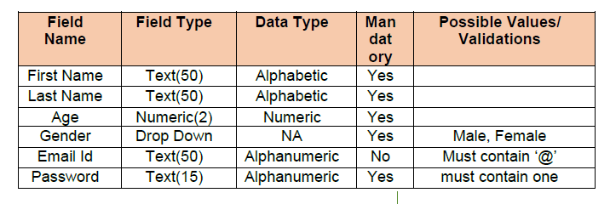

User/Admin login:
Column Name | Data Type | Length | Nulls
User Id/Admin Id | nvarchar | 50 | N
Password | nvarchar | 50 | N

NGO Registration:
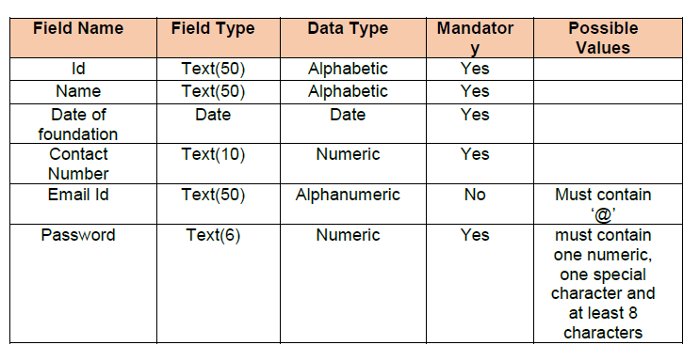
Event Information:
